**On Premises Data Gateway :**

Before you can [connect to on-premises data sources from Azure Logic Apps](https://docs.microsoft.com/en-us/azure/logic-apps/logic-apps-gateway-connection), download and install the [on-premises data gateway](https://aka.ms/on-premises-data-gateway-installer) on a local computer. The gateway works as a bridge that provides quick data transfer and encryption between data sources on premises and your logic apps. You can use the same gateway installation with other cloud services, such as Power Automate, Power BI, Power Apps, and Azure Analysis Services.

The on-premises data gateway acts as a bridge. It provides quick and secure data transfer between on-premises data, which is data that isn't in the cloud, and several Microsoft clouds services. These services include Power BI, Power Apps, Power Automate, Azure Analysis Services, and Azure Logic Apps. By using a gateway, organizations can keep databases and other data sources on their on-premises networks while securely using that on-premises data in cloud services.

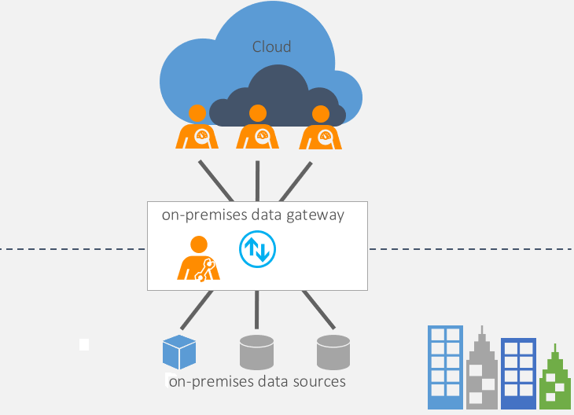

There are two different types of on-premises data gateways, each for a different scenario.

* **On-premises data gateway**: Allows multiple users to connect to multiple on-premises data sources. With a single gateway installation, you can use an on-premises data gateway with all supported services. This gateway is well suited to complex scenarios where multiple people access multiple data sources.
* **On-premises data gateway (personal mode)**: Allows one user to connect to data sources and can’t be shared with others. An on-premises data gateway (personal mode) can be used only with Power BI. This gateway is well suited to scenarios where you’re the only one who creates reports and you don't need to share any data sources with others.